USER GUIDE

UPDATE ERROR types

August 2018

Version 1.02

Pharmacon ITC303/309 Group

Document Revisions

|  |  |  |
| --- | --- | --- |
| Date | Version Number | Document Changes |
| 30/08/2018 | 1.01 | Initial Draft |
| 30/08/2018 | 1.02 | Draft |
|  |  |  |
|  |  |  |
|  |  |  |
|  |  |  |
|  |  |  |
|  |  |  |
|  |  |  |

Table of Contents

1 Introduction 4

1.1 Scope and Purpose 4

1.2 Process Overview 4

2 Update Error Types 5

2.1 Update Error Type 5

2.1.1 To Update an Error Type: 5

# Introduction

## Scope and Purpose

The purpose of this user guide is to provide instructions on how to update an error type that has already been entered and requires correction. No other features of the Pharmacy Error Tracker (PET) application will be discussed in this user guide.

* To be able to use PET, the user will need basic knowledge of logging into an online application and using a search function to locate records.
* To be able to search Error Types within PET.
* This feature is only available to a user with administrator rights.

## Process Overview

The administrator will need to log into PET using their valid username and password.

* The Welcome Page will be presented on successful login.
* The administrator will need to select Search Error Types via the menu bar or the button on the menu page.
* The user is to enter a search criterion.

# Update Error Types

User must have loaded the error type into the Error Details form.

User must know what the field is to be updated to.

## Update Error Type

User must have access to the application.

User must have a valid username and password with administration rights.

### To Update an Error Type:

1. To update details of the error type, select the record by clicking on the to the right of the record.

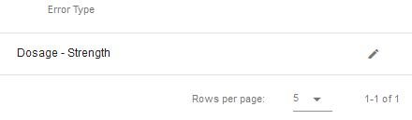

1. The selected record will load into the Error Type Details form, providing full error type information

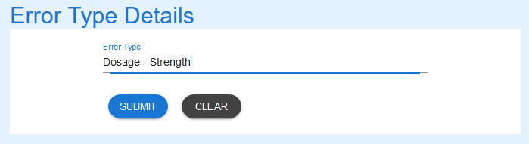

1. Amend the record as required.

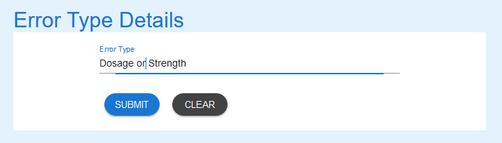

1. Select the “Submit” button to update the record in the database. A message stating record has been updated successfully is returned.

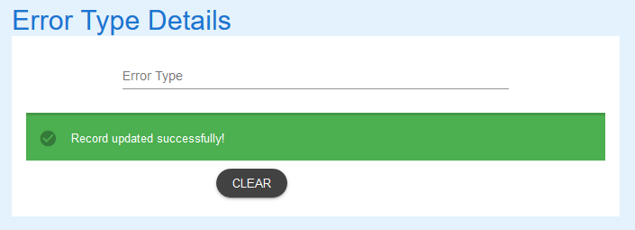

1. A search for “dos” shows the record has been updated

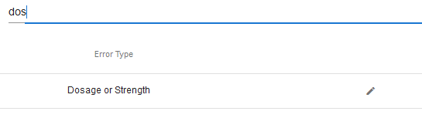

If you encounter issues not addressed by this user guide, please contact your account manager for additional support.